DS Urbanisation

The Team:

Zied Kannoun

Marwen Krichen

Yassine Lassoued

Groupe 1

1. Database Setup

The first thing that we did is creating the database, we chose MongoDB.

Then we created a collection for the employees with some documents to test with them the CRUD functions

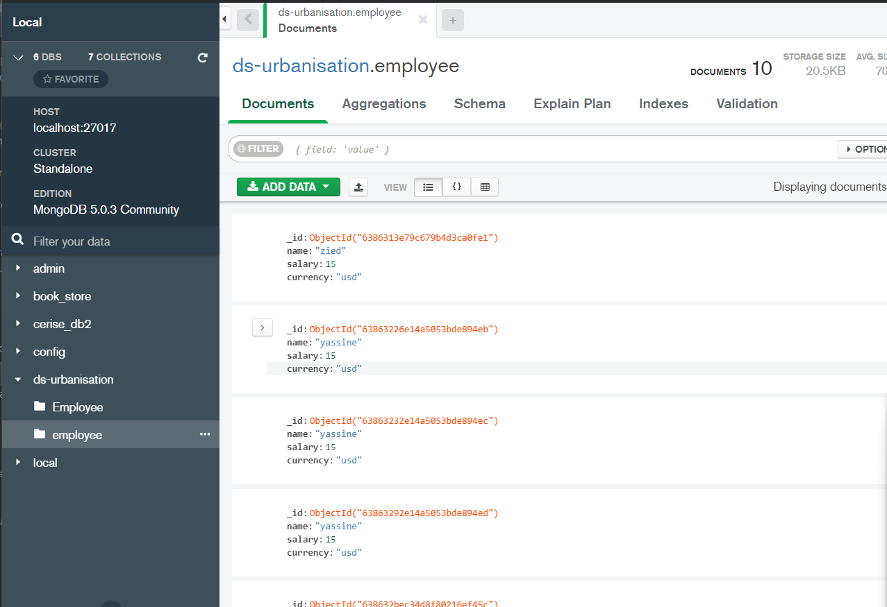

1. Backend Environement

We created the backend server with Flusk, then we had to ensure the database connection with mongodb and then we exposed some CRUD APIS

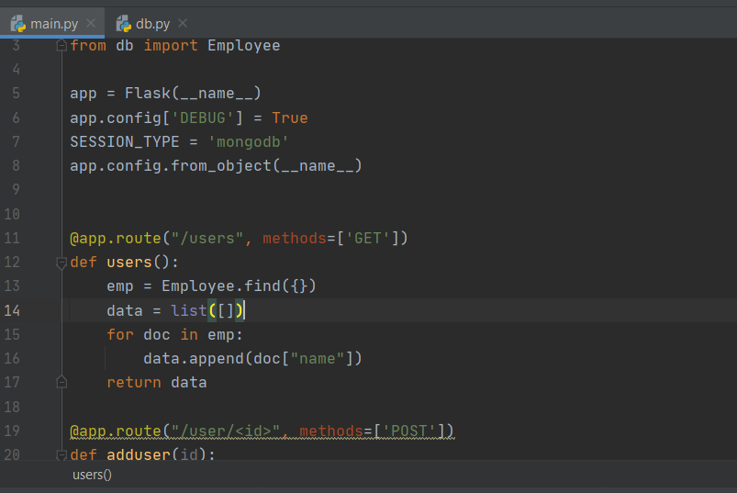

1. API Description

With the help of Anypoint Designer we created a RAML file to define our APIS descriptions that respects the best practices of API creation as stated by APIGee

You can find in the zip the employee.raml

1. Expose the API

We created a Mule project in Anypoint Designer that consumes some APIS as shown below

You can find in the zip file submitted the project